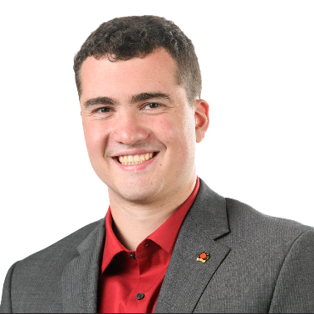Andrew MacBeath

I am a sports producer with experience in social media content, live production, and writing feature stories. I am experienced in master control rooms, collegiate athletics programs, and beat reporting with more than three years’ relevant working experience. I have a diverse skill set and am well-versed in a variety of roles as part of a production team and sports broadcasting environment.

Experience

Operations Technician, New England Sports Network Apr 2024 - Present

* Manage broadcast on primary and outer markets, quality check broadcast elements and sponsorships, manage external shows and games for rebroadcast

Freelance Production Assistant, Various Sept 2020 – Present

* Operated cameras, replay, graphics, produced, and directed 70+ Division I collegiate athletic events for local and network broadcasts
* Created video content and wrote press releases for the Pioneer Baseball League
* Assisted in production and management for the Call of Duty League Major event in Boston, MA

Multimedia Journalist, 13WHAM News Aug 2023 – Nov 2023

* Presented breaking news and features on air, shot and edited daily stories, wrote for broadcast and print platforms

Sports Illustrated, Sports Beat Reporter Jan 2023 – June 2023

* Wrote college lacrosse articles for Sports Illustrated Syracuse on Fan Nation

Copy Editor, WAER Jan 2023 – May 2023

* Edited radio stories for print publishing, managed SEO, created social media posts

Education

M.S. Broadcast and Digital Journalism, Syracuse University Graduated 2023

* Magna Cum Laude, earned merit scholarship

B.A. Sports Media, High Point University Graduated 2022

* Magna Cum Laude, Minor in Athletic Coaching, earned Honors Scholar and merit scholarship

Skills

* Adobe Certified Professional in Digital Video using Adobe Premiere Pro 2023
* Photoshop, After Effects, Avid, ENPS, iNews
* Canon, Sony, and Hitachi camera equipment, standard control room software and hardware
* AP style writing/editing, press release writing

Contact

Email: [a.n.macbeath@gmail.com](mailto:a.n.macbeath@gmail.com)

Phone: 781-548-1410

Website: [HOME | MacBeath Media](https://www.andrew-macbeath.com/)

LinkedIn: [Andrew MacBeath | LinkedIn](https://www.linkedin.com/in/andrew-macbeath/)